**SREE CAUVERY EDUCATIONAL INSTITUTIONS, KUVEMPUNAGAR, MYSORE – 570 023**

**SREE CAUVERY FIRST GRADE COLLEGE**

**UNIVERSITY OF MYSORE**

**B.Com VI SEMESTER DISTINCTION HOLDERS AUGUST 2023**

**CENTUM SCORERS & DISTINCTION HOLDERS**

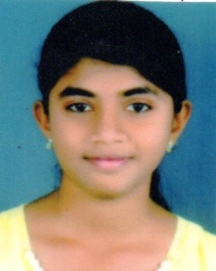

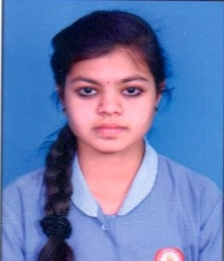

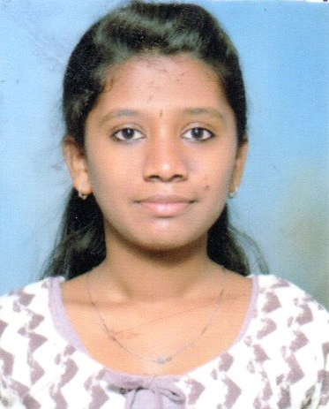

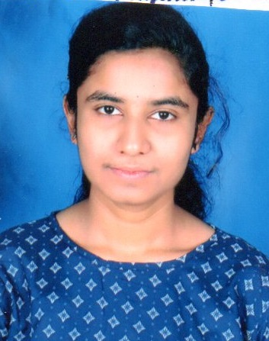

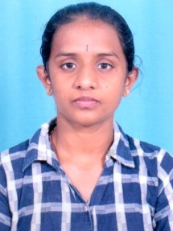



Dakshayini.N Suchithra.P Bhavani.S Deepak.S Sonu.G Sushmitha.L

GPA : 9.91 GPA : 9.85 GPA : 9.72 GPA : 9.74 GPA : 9.41 GPA : 9.24

ACMA-II : 100/100 ACMA-II : 100/100 QDT : 100/100 ACMA-II : 100/100 IT – II : 100/100 QDT : 100/100

IT – II : 100/100 QDT : 100/100 PPA : 100/100

PPA : 100/100 BL : 100/100

**CENTUM SCORER : BBA**

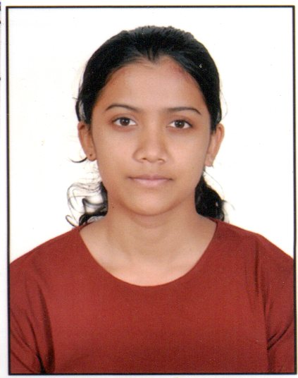

**Ankitha.B.A**

**GPA :9.4**

**BS : 100/100**

**DISTINCTION HOLDERS : B.Com**



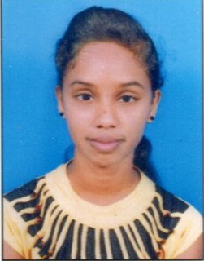

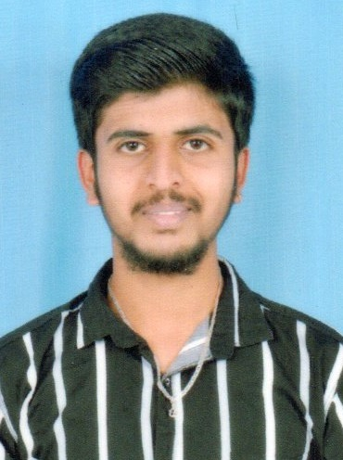



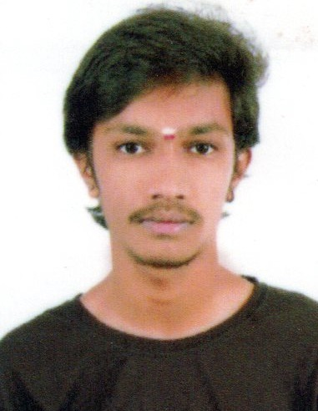



Monisha.M.A Sudeep.S.P Harshitha.G Varun.D Vidya.V Keerthana.L.K

GPA : 9.17 GPA : 9.09 GPA : 9.06 GPA : 8.85 GPA: 8.85 GPA : 8.82

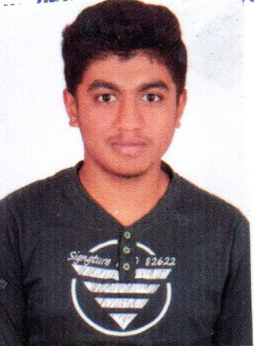

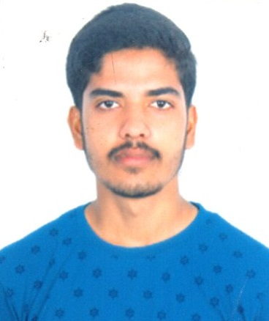





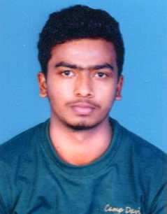



Nathin Rounak Nisarga.D Sathish.M Prashanth.M Syed Roshan.M Tejas.K.S

GPA : 8.69 GPA : 8.63 GPA : 8.52 GPA : 8.41 GPA : 8.32 GPA : 8.30

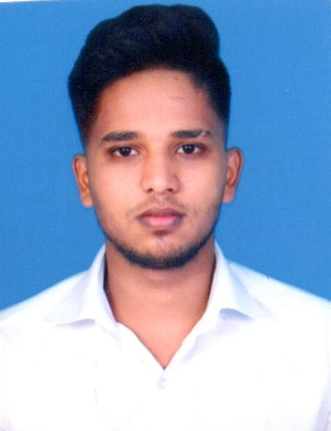

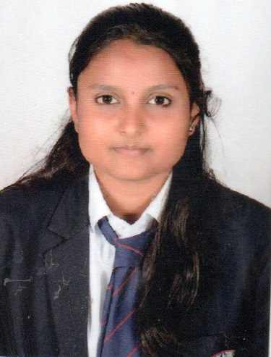

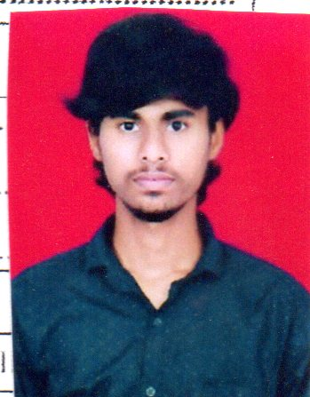



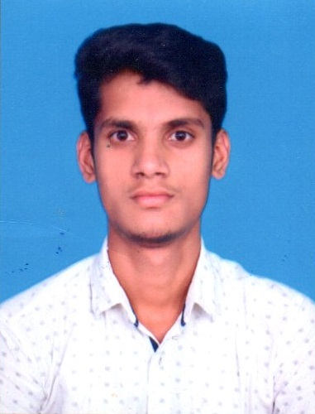

Rajesh.M Abhishek.V Dharanesh.M.R Nisarga R.Abhishek

GPA : 8.08 GPA : 8.07 GPA : 8 GPA : 8 GPA : 8